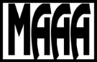 | Millersburg Area Art Association, Inc. | 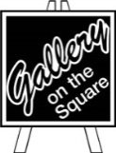

ARTIST INVENTORY LIST
Artist Name:

Address:

Phone:

All work displayed at the Gallery on the Square or its’ satellite exhibit spaces is on a consignment basis with the Millersburg Area Art Association Inc. The Gallery will deduct a 20% commission from the selling price for MAAA members and a 40% commission for non-members. A 30% commission will be deducted from artists who are members of an organization with an organizational membership, during that organization’s show at the Gallery.

Although the greatest possible care will be taken in handling all artwork, the Gallery on the Square and the Millersburg Area Art Association does not accept responsibility for any damage or theft which may occur. All artwork is submitted at the artist’s own risk.

Artist’s Signature |  | Date

# | Item Name | Medium | Price | Date  submitted | Date  retrieved / sold
1
2
3
4
5
6
7
8
9
10
11
12
13

Artist Name:

# | Item Name | Medium | Price | Date  submitted | Date  retrieved / sold
14
15
16
17
18
19
20
21
22
23
24
25
26
27
28
29
30
31
32
33
34
35
36
37
38
39

